Supplementary Material
Riverscape genetic structure of a threatened and dispersal limited freshwater species, the Rocky Mountain Sculpin (Cottus sp.)
Jonathan L.W. Ruppert^{1*}, Patrick M.A. James², Eric B.Taylor³, Tyana Rudolfsen¹, Marie Veillard¹, Corey S. Davis⁴, Doug Watkinson⁵ and Mark S. Poesch¹
¹ Department of Renewable Resources, University of Alberta, Edmonton, Alberta
² Départment de Sciences Biologiques, Université de Montréal, Montréal, Québec
³ Department of Zoology and Biodiversity Research Centre and Beaty Biodiversity Museum,, University of British Columbia, Vancouver, British Columbia
⁴ Molecular Biology Service Unit (MBSU), Department of Biological Sciences, University of Alberta, Edmonton, Alberta
⁵ Fisheries and Oceans Canada, Central and Arctic Region, Winnipeg, Manitoba

Tables
Table S1. Primer sequences, observed size ranges and PCR multiplex conditions for 11 microsatellite loci.
Locus | Forward Primer Sequence | Reverse Primer Sequence | Size Range (bp) | Mix | [Primer] | T_{a}
Cba42 | TET-AAATGGTCGTCTGCTCCCTG | AGGCAGTGTGGGCATGAAAG | 106-140 | 1 | 0.2µM | 57ºC
Cco02 | 6FAM-TTCTTGTTCTCCGTCTTGAGC | CCCATCTTCTCCTCCTGTCC | 236-299 | 1 | 0.6µM | 57ºC
Cco13 | TET-CCTGGAATTTCACCAAGGTC | TCACAACAAAGCCAGAGGAC | 218-224 | 1 | 0.2µM | 57ºC
Cco15 | HEX-TTGGCACATTGTGGAGACTG | TGGAAAAGTTGTTCTTGTAACG | 159-234 | 1 | 0.2µM | 57ºC
Cco17 | 6FAM-TCGTCTTGGAAATGGAAAGC | CATGTCAGCAGGATATCACGTC | 93-159 | 1 | 0.6µM | 57ºC
Cgo114 | HEX-GTGACTGAGCCTTGAGATTC | GAACCAACGGAAATGAAAC | 123-131 | 1 | 0.2µM | 57ºC
Cgo310 | HEX-CACTGTCATGTAGCGGCTC | AGAACCAGTGTTTGACTCTGC | 180-256 | 2 | 0.6µM | 55ºC
Cott130 | HEX-TCTGGATCCCTCGGACCAGG | TGAGCTCCATCGTGGGTTCG | 139-151 | 2 | 0.2µM | 55ºC
Cott687 | 6FAM-TGTACCTAGTGAGCCTGCTG | CGTCAGCATCTACTGGGCAG | 140-190 | 2 | 0.4µM | 55ºC
CottES10 | TET-CAGGCGGCGACACGGTG | TTATGAGGAGTCTGCCAATGCAG | 176-188 | 2 | 0.2µM | 55ºC
CottES19 | TET-CCCCTTCCGTGAGCGACG | ATATCACAGCACTTTTGGGGATG | 122-139 | 2 | 0.1µM | 55ºC
Note: 6FAM, TET and HEX indicate flourophores on 5” end of forward primer; T_{a} = annealing temperature; Mix = coamplification (multiplex) group.

Table S2. Summary of diversity measures for each site. Included is the location (basin or sub-basin), site number, sample size (n), number of alleles, observed heterozygosity (H_{o}), and unbiased expected heterozygosity (H_{e;} Nei 1973). Values in brackets represent the standard deviations. All values, except for allelic richness were calculated in GenAIEx 6.5.
Location | Site | n | No. of Alleles† | H_{o} | H_{e}
Flathead River | 1 | 25 | 2.14 (1.11) | 0.26 (0.09) | 0.26 (0.09)
 | 2 | 28 | 2.33 (0.95) | 0.29 (0.08) | 0.30 (0.08)
 | 3 | 24 | 2.10 (1.10) | 0.26 (0.09) | 0.27 (0.09)
 | 4 | 21 | 2.09 (1.12) | 0.27 (0.08) | 0.28 (0.09)
 | 5 | 29 | 2.26 (1.19) | 0.26 (0.08) | 0.26 (0.08)
 | 6 | 21 | 2.15 (1.12) | 0.25 (0.08) | 0.26 (0.08)
 | 7 | 22 | 1.88 (0.97) | 0.24 (0.09) | 0.24 (0.09)
Lee Creek | 8 | 30 | 3.60 (1.84) | 0.49 (0.09) | 0.50 (0.10)
 | 9 | 30 | 3.59 (1.56) | 0.51 (0.08) | 0.52 (0.08)
 | 10 | 21 | 3.61 (1.53) | 0.54 (0.08) | 0.56 (0.08)
 | 11 | 30 | 3.68 (1.64) | 0.54 (0.09) | 0.55 (0.09)
 | 12 | 30 | 3.87 (1.68) | 0.55 (0.08) | 0.56 (0.08)
 | 13 | 30 | 3.80 (1.73) | 0.53 (0.08) | 0.54 (0.08)
 | 14 | 30 | 3.76 (1.57) | 0.58 (0.07) | 0.59 (0.07)
 | 15 | 22 | 3.59 (1.86) | 0.55 (0.09) | 0.56 (0.09)
 | 16 | 28 | 3.70 (1.46) | 0.57 (0.06) | 0.58 (0.06)
 | 17 | 29 | 3.87 (1.69) | 0.56 (0.07) | 0.57 (0.07)
 | 18 | 11 | 3.89 (2.15) | 0.58 (0.07) | 0.61 (0.08)
 | 19 | 30 | 4.03 (1.85) | 0.58 (0.06) | 0.59 (0.06)
St. Mary River | 20 | 30 | 3.90 (1.84) | 0.55 (0.07) | 0.56 (0.08)
 | 21 | 30 | 3.95 (1.93) | 0.59 (0.07) | 0.60 (0.07)
 | 22 | 30 | 4.02 (1.96) | 0.59 (0.06) | 0.60 (0.07)
 | 23 | 29 | 3.95 (1.80) | 0.58 (0.07) | 0.59 (0.07)
 | 24 | 30 | 4.13 (1.87) | 0.60 (0.07) | 0.61 (0.07)
 | 25 | 29 | 4.11 (1.93) | 0.60 (0.06) | 0.61 (0.06)
 | 26 | 30 | 4.04 (1.98) | 0.57 (0.07) | 0.58 (0.07)
 | 27 | 30 | 4.28 (2.11) | 0.59 (0.08) | 0.60 (0.08)
 | 28 | 30 | 3.95 (1.83) | 0.57 (0.07) | 0.58 (0.07)
North Milk River | 29 | 30 | 3.99 (1.93) | 0.52 (0.08) | 0.53 (0.08)
 | 30 | 27 | 3.7 (1.78) | 0.53 (0.08) | 0.54 (0.08)
 | 31 | 30 | 3.94 (2.10) | 0.55 (0.08) | 0.56 (0.08)
 | 32 | 30 | 3.94 (2.18) | 0.52 (0.08) | 0.53 (0.08)
 | 33 | 27 | 3.93 (2.05) | 0.56 (0.08) | 0.57 (0.08)
 | 34 | 24 | 3.16 (1.55) | 0.51 (0.08) | 0.52 (0.08)
 | 35 | 29 | 3.19 (1.57) | 0.52 (0.08) | 0.53 (0.08)
 | 36 | 29 | 3.37 (1.61) | 0.52 (0.08) | 0.53 (0.08)
 | 37 | 30 | 3.28 (1.54) | 0.52 (0.08) | 0.53 (0.08)
†Allelic richness estimated using rarefied counts; richness is rarefied to 11 diploid individuals (hierfstat in R).
Table S3. Hardy-Weinberg equilibrium test results by location. P-values are given for the upper tail and were Bonferroni corrected for multiple tests (P<0.05/# of tests). Bold p-values designate those tests that exceed the significance level.
Location | Cba42 | Cgo114 | Cco02 | Cco13 | Cco15 | Cco17 | CottES10 | Cott130 | Cott687
Flathead River | 0.82 | 0.51 | 0.34 | 0.97 | 1.00 | 0.70 | 0.97 | 0.97 | 0.99
Lee Creek | 0.15 | 0.36 | 0.22 | 0.68 | 0.15 | 0.69 | 0.50 | 0.94 | 0.70
St. Mary River | 0.61 | 0.13 | 0.85 | 0.87 | 0.00 | 0.12 | 0.68 | 0.42 | 0.60
North Milk | 0.95 | 0.97 | 0.91 | 0.86 | 1.00 | 0.43 | 0.49 | 0.90 | 1.00

Table S4. Pairwise F_{ST} values (lower diagonal) and the associated p-values (upper diagonal) between sites within the study. Significance was tested at the α = 0.01 level using bootstrapped F_{ST} values from the diffcalc function in the diveRsity package in r software.

Figure S1. Sample sizes and genetic diversity measures at each site plotted geographically. Included is (A) sample size (n), (B) number of alleles, (C) observed heterozygosity (H_{o}), and (D) unbiased expected heterozygosity (H_{e;} Nei 1973).
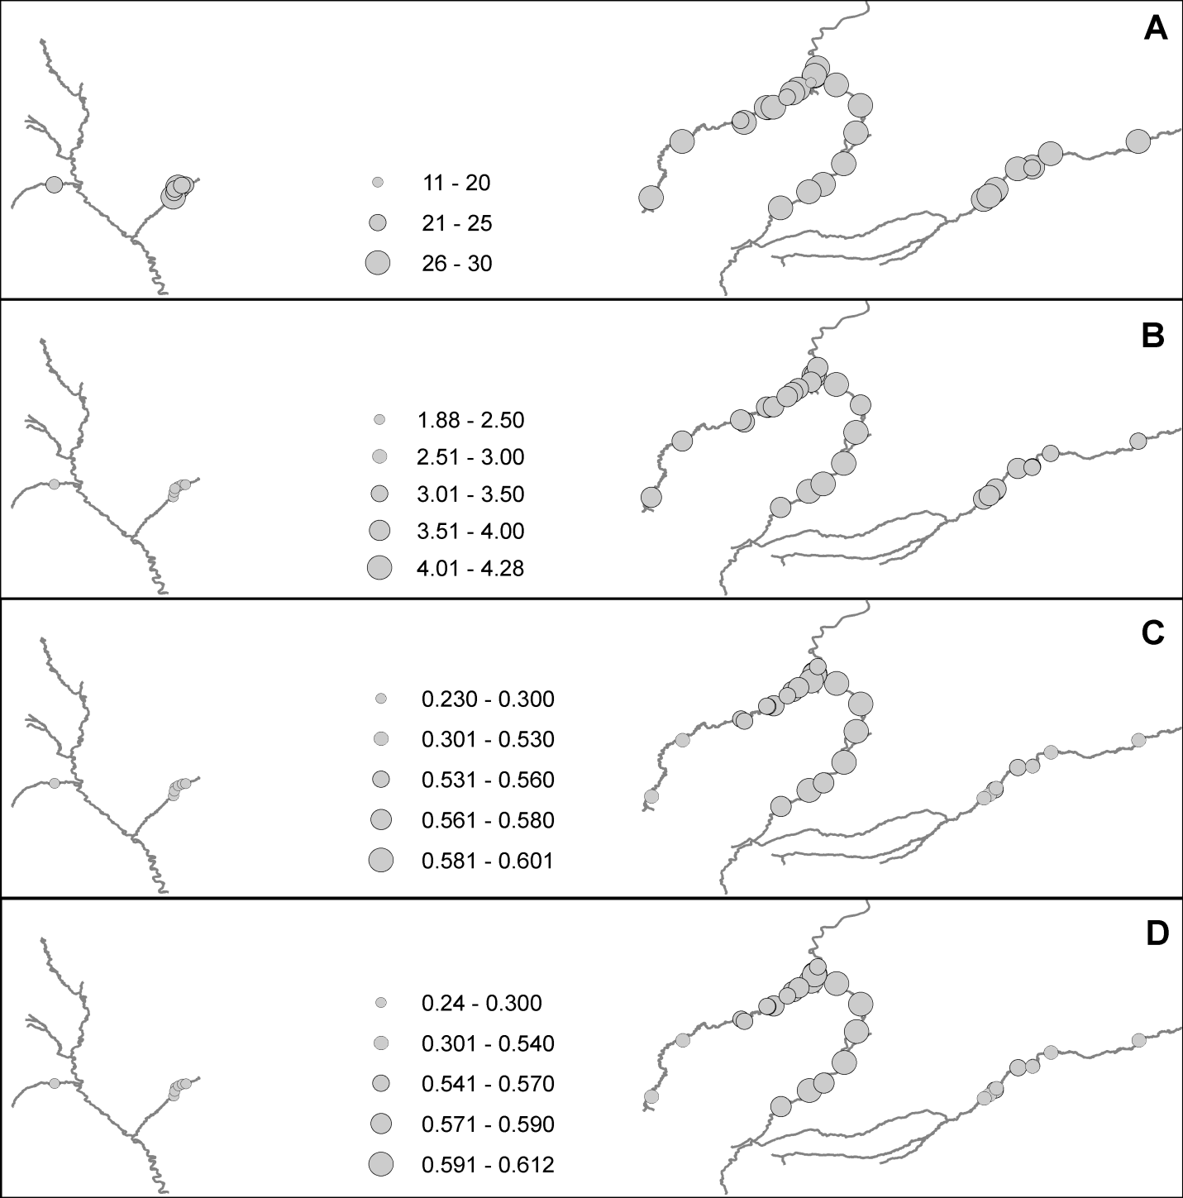
Figure S2. STRUCTURE results showing the (A) mean of estimated ln probability of different group sizes (K) with bars denoting standard deviations. (B) The corresponding Delta K value across different group sizes (K) via the Evanno et al. (2006) method are also shown.
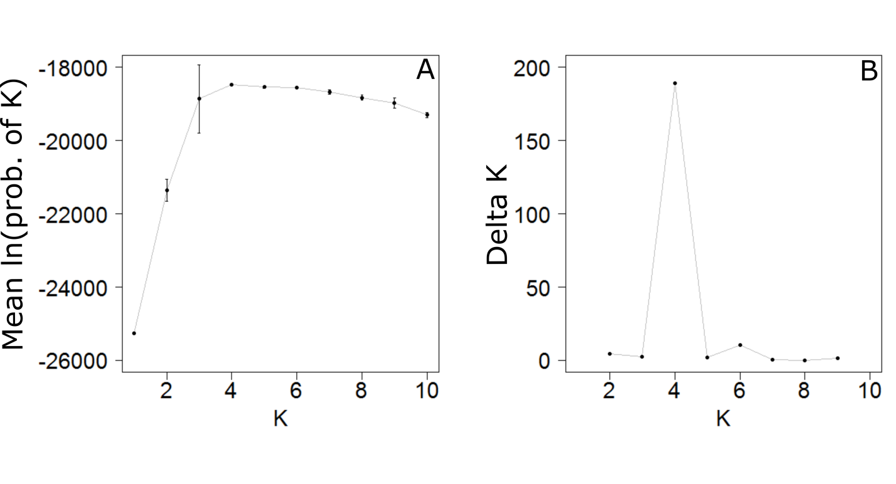
Figure S3. STRUCTURE results for individuals from Lee Creek and St. Mary River showing the (A) mean of estimated ln probability of different group sizes (K) with bars denoting standard deviations. (B) The corresponding Delta K value across different group sizes (K) via the Evanno et al. (2006) method are also shown.
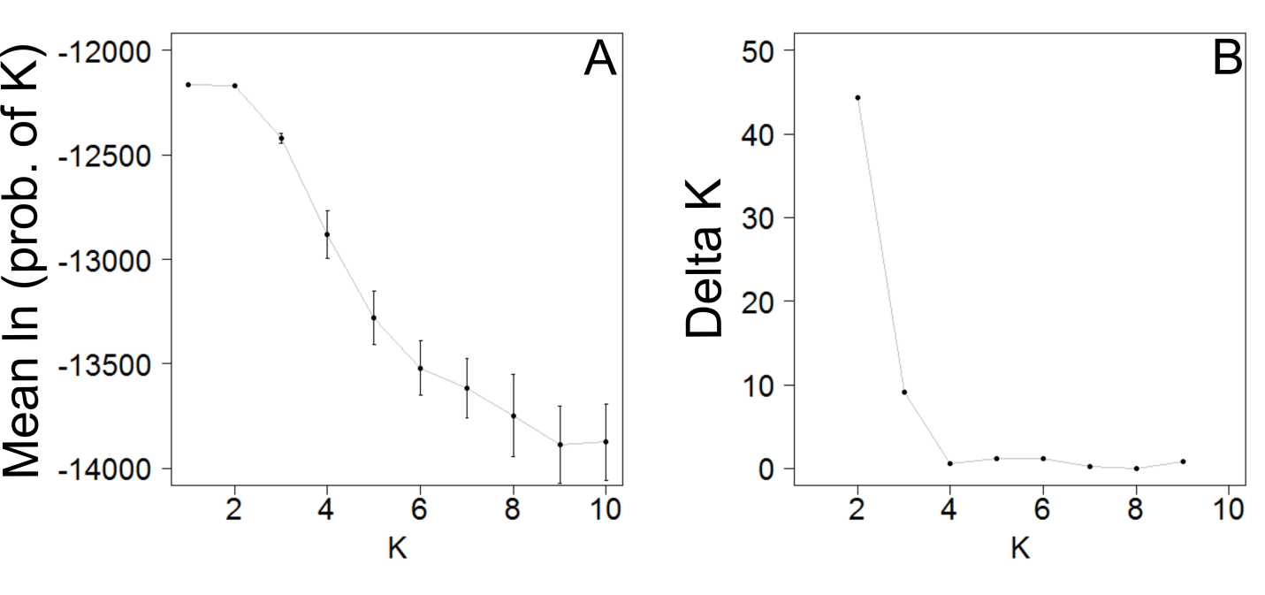

Figure S4. Results from one run of GENELAND using 500,000 iterations, correlated allele frequencies, and a maximum of 10 populations. Shown is the (A) number of clusters or populations (K; not shown is that multiple runs (10) confirm that K = 4), alongside the probability of population assignment for (B) cluster 1, (C) cluster 2, (D) cluster 3 and (E) cluster 4 for all sample sites.
